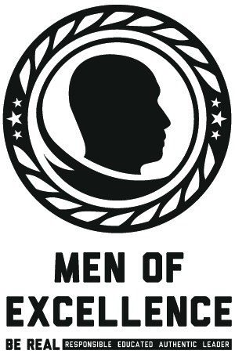
4TH ANNUAL MEN OF EXCELLENCE CONFERENCE
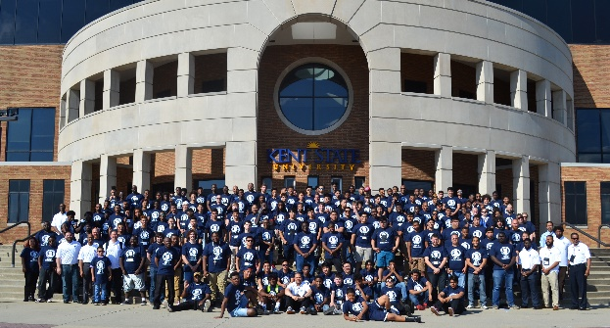
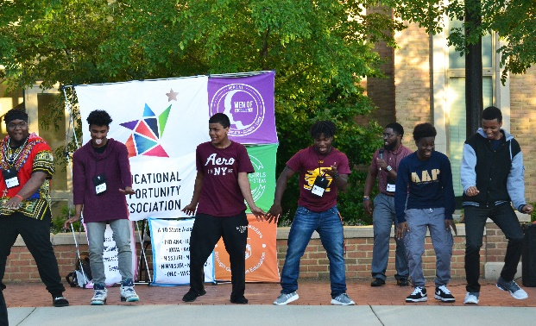

The EOA Men of Excellence Committee is excited to host the 4th Annual Men of Excellence Conference
May 31 - June 2, 2018 on the University of Northern Iowa campus in Cedar Falls Iowa. Inspired by President Obama's “My Brother's Keeper” initiative; this conference targets young men from pre-college and collegiate programs. Attendees will work with TRIO/Higher Education Access and Community professionals on personal and college planning along with life skills development. Each programs can nominate up to ten (10) students who are interested in hands-on activities and learning about developing and being better men. Registration will be capped at 250 selected participants.
CONFERENCE DATE: May 31 – June 2, 2018
LOCATION: University of Northern Iowa, Cedar Falls, Iowa
AIRPORT INFORMATION: Conference attendees will have the choice to fly into the Waterloo Regional Airport or The Eastern Iowa Airport located in Cedar Rapids Iowa. The Waterloo Regional Airport is located within a 15-minute drive. The Eastern Iowa Airport is 67 miles or an hour drive. Attendees with have access to auto rental companies at both airports.

Waterloo Regional Airport The Eastern Iowa Airport
2790 Livingston Lane Arthur Collins Pkwy SW
Waterloo, Iowa 50703 Cedar Rapids, Iowa 52404
Phone: (319) 291-4483 Phone: (319) 362-8336

APPLICATION DEADLINE: April 20, 2018 (Applicants must apply & be accepted BEFORE they register!)
REGISTRATION COST: $325 per participant, which includes meals, conference materials, and lodging.
QUESTIONS? Contact men-of-excellence@eoa.org or wilfred.johnson@uni.edu
CONFERENCE HIGHLIGHTS
- College Campus and Academic/Career Fair
- Discussion on Timely Issues Facing Men

- Empowering Men Panel Discussion
- Self-Discovery Sessions (Exploring Manhood)

Motivational speakers – including banquet keynote speaker: Mr. James McBride Writer, Composer and Musician.

